**THE 5th INTERNATIONAL UNDERGROUND EXCAVATIONS SYMPOSIUM AND EXHIBITION**

GUIDELINE FOR PREPARATION OF PAPERS

The manuscript should be prepared according to rules given in this guideline. The rules are important to provide the uniformity throughout the proceedings.

Furthermore, a file named **"Paper Format.docx"** prepared according to the rules is attached for the author’s usage during typing the manuscript. Some lines (title, authors, main and sub headings) are defined with "click and type macro", so that they can be typed directly after clicking on them. When the number of headings are not sufficient it can be added by copy/paste method.

Camera-ready manuscript will be reduced to **75%** of original size. Therefore, the manuscript

should be typed in **Times New Roman, 14 point**, to provide easier reading of printed material.

**1) Typing Area:**

* The typing area is 187 mm in width and 272 mm in height on A4 paper size.
* The paper should be prepared in a single column format.
* The whole paper should be limited by 12 pages.

**2) Title and Author(s):**

* Title (max. 75 characters) should be typed with 20 point in the given field. Author(s) name(s) with 16 point.
* Affiliations in italic with 14 point.

**3) Abstract:**

* ABSTRACT (14 point, Bold) should be not more than 150 words but justified. The second paragraph (in case) must start inside 5 mm from the left block
* Two lines should be left at the end of abstract and then main text is typed in single columns.

**4) Headings:**

* • All types of headings are 14 points, and they are numbered as 1 the right of the last digit 1.1 1.2.1 without a dot on
* Headings;

Main headings : **1 FULL CAPITAL, 14 POINT, BOLD**

Primary sub-heading : **1.1 First Letters Capital, 14 Point, Bold**

Secondary sub-heading : ***1.1.1 Only the first letter capital, 14 point, italic, bold***

Tertiary sub-heading : *1.1.1.1 Only the first letter capital,14 point, italic, not bold*

**5) Paragraphs:**

* The paragraphs should be justified and the letters should not be hyphenated
* No gap is left between the preceding paragraphs.
* The paragraph following a heading or a gap should start from left, otherwise 5 mm inside.

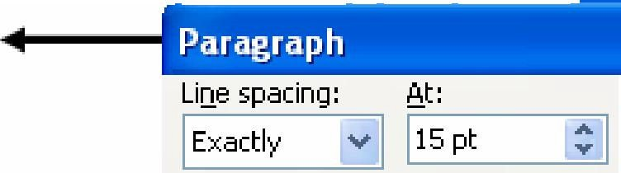

* Line spacing must be selected "exactly 15 pt".

**6) Tables, Figures, Photos, Equations:**

* Tables and figures (photos) should be numbered in order and given just after the paragraph mentioned.
* The title of table must be written above it as shown below (Spacing)
* Vertical and horizontal lines must be used as minimum as possible, similar to the one given below.

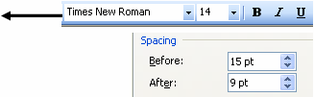

Table 1. Sample characteristics

|  |  |  |  |  |
| --- | --- | --- | --- | --- |
| Sample  no | Height  (cm) | Diameter  (cm) | Failure Load  (kN) | Strength  (Mpa) |
| 1 | 12.34 | 5.53 | 12,000 | 32.25 |
| 2 | 13.02 | 5.43 | 13,500 | 36.43 |
| 3 | 12.87 | 5.46 | 15,200 | 45.62 |
| 4 | 12.56 | 5.48 | 14,650 | 39.24 |

The title of figure must be written below it as follows (Spacing)

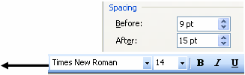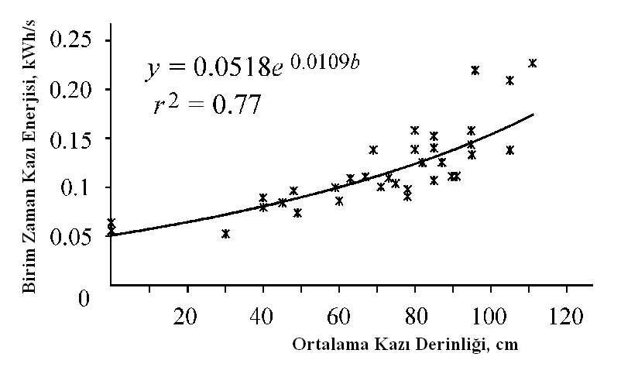

Figure 1. Depth-energy relationship

* Equations must start from left and typed by using an equation editor. They must be numbered in an order and referred in the text.
* Variables used in the equation must be explained just below it, with their units

**7) The following examples should be used about Abbreviations, References, Units, footnote when necessary:**

* When they are used in text; use Table 1, Figure 1, Figures 2-4, 8a, b etc. (not abbreviated)
* When they are given in parentheses; use Tab. 1, Fig. 1, Figs. 2-4, 8a, b etc
* (abbreviated)
* (Author 1989a, b, Author & Author 1987) instead (Author, 1989a,b; Author&Author,1987)
* SI units must be preferred:

kg / m / kJ / cm instead kg. (Kg) / m. / kJ (KJ) /cm.;

20o16'32'' SW instead 20o16,32,, SW; x 20 / x 20 instead *20 / X20; 4 + 5 > 7 instead

4+5>7

* No footnote must be given in the text. When it is used in tables, *, **, ♣, etc. symbols are used and they must be described just below the table with a smaller size (e.g., 12 for 14 point, or 10 for 12 point)

**8) References :**

* The references should be written in the text by using connecting word method. The references in the text should be written as the surname(s) of the author(s) and the year of the source(s). If the author’s name is missing, then the name of the institution should be replaced to the author’s name. For example; (Esen, 2002), (Abisel, 1996), (Richardson et al., 2000a), (Ünal vd., 2009), (DPT, 2004).
* References mentioned in the text must be listed at the end in alphabetical order with 12

point in size. Heading (REFERENCES) must not be numbered.

* The bibliography should start from the page where the article is finished and the indentation of the first line should be 1,25 cm. The works should be arranged in the alphabetical order of the surnames of the authors. When referring to multiple studies of the same author, the order should start with the one which has the oldest publication date. When referring to multiple studies of the same author which have the same publication dates, the sources should be numbered by using a, b, c, e.t.c. both in the bibliography and in the in text referring (i.e: 2009a, 2009b, 2009c, e.t.c.). When referring to a study of an author which has single and multiple authors, the single authored studies should be declared first. The bibliographies and statements should not be stated as footnotes in the text.
* References must be written in justified format and the second lines must start 5 mm

inside. No gap is left between preceding references. Examples are;

Surname, Initial(s), (ed.), year. Book name, Publisher, City, page amount (e.g.,

271 p.).

Surname, Initial(s), (ed.), year. Title of article, Magazine name (serial number if needed), volume, circle, page interval (e.g., pp.46-52).

Surname, Initial(s), (ed.), year. Title of paper, Congress, Symposium, etc. name

(serial number if needed), volume, page interval (e.g., pp.46-52).

WCI (World Coal Institute) 2007. Report on New Production Technologies in Coal

Mining. No. 2733 - 684): Paris.

MAUSS, M. (1967), New Production Technologies in Coal Mining, Translated: Ian Gunnison, W. W. Norton& Company Inc., New York, ht[tp.www.web.mit](http://www.web.mit/) eduallanmcwwwmauss1 pdf , (Accession date: 20.02.2008).

**9) Sending Manuscript :**

* The manuscript should be submitted to **Contact** address via e-mail not later than the deadline.